Outcome Statement — Automated RFP-to-Project Initiation
California State Health Care Application · UX Enhancement (based on Kansas Health Care System design)
Oct 30, 2026 · Prepared by @Subhashini · Version 1.0 — Draft for sign-off

Context
California has issued an RFP to enhance the UX of its state health care application, and we will reuse our proven Kansas Health Care System design as the baseline. Today the path from RFP receipt to an initiated project is manual: requirements are re-read, Kansas assets are hunted down by hand, and the charter is assembled across email. That costs weeks and risks missing California-specific mandates.

Outcome Statement
By the end of the initiation phase, an automated RFP-to-Project flow will turn the California RFP into an approved, stakeholder-signed Project Charter within 10 business days of RFP receipt. Every California requirement will be traced to a reused Kansas UX asset or a scoped enhancement, compliant with CA accessibility, privacy and language-access mandates.
Who benefits: CA program sponsors get a faster, auditable start; delivery teams start from a validated design baseline instead of a blank page.

Automated Flow
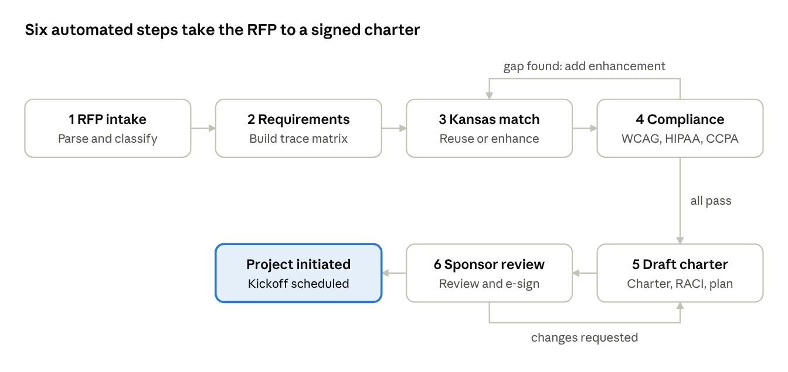
RFP-to-project flow · 6 steps, 2 human gates
Steps 1–3 and 5 are automated (AI extraction, asset matching, charter drafting); compliance and sponsor review are human-validated gates that loop back until they pass.

Scope
In scope | Out of scope
RFP intake, parsing and requirement extraction | Full UX redesign from scratch
Gap analysis: Kansas UX baseline vs CA requirements | Build and deployment of the CA application
Auto-drafted charter, RACI, high-level estimate and roadmap | Contract negotiation and pricing approval
CA compliance checks: WCAG 2.1 AA / Section 508, HIPAA, CCPA/CMIA, CA language access | Back-end integrations (eligibility, Medi-Cal MMIS)
Stakeholder review and e-sign-off | Post-initiation delivery phases
Assumptions: Kansas design assets (design system, journeys, research) are licensed for reuse; the CA RFP is available in machine-readable form; a named CA sponsor is available for reviews within 2 business days.

Success Measures
Measure | Target
RFP receipt to signed charter | ≤ 10 business days (vs ~6 weeks manual)
CA requirements traced to an asset or enhancement | 100%
Kansas UX assets reused in the CA baseline | ≥ 60%
Compliance checks passed before sign-off | 100% of mandatory items
Manual effort in initiation | ≥ 50% reduction
Stakeholder sign-off rounds | ≤ 2

Risks and Dependencies
- Policy differences (KanCare vs Medi-Cal): eligibility rules and content differ; mitigated by a human review gate on every gap item.
- Asset licensing: reuse of Kansas IP needs written clearance before the baseline is locked.
- AI extraction accuracy: misread requirements; mitigated by SME validation of the requirement matrix.
- Dependency: timely CA sponsor and procurement-office reviews.

Stakeholder Sign-off
By signing, the stakeholders below approve this outcome, its scope and its success measures as the basis for project initiation.
Role | Name | Decision | Signature | Date
Executive Sponsor (CA DHCS / Program)
Product Owner
UX Design Lead
Compliance / Privacy Officer
Delivery / PMO Lead

